SAE Planning

*Created: 02/2015 by the National FFA Organization*

Student Learning Objectives

After completing these activities students will…

1. Develop a specific SAE plan and description.
2. Create SMART goals for his/her SAE.
3. Plan a timeline for SAE development, implementation, and evaluation.
4. Estimate the financial requirements for his/her SAE.

Time Required: 15-30 minutes per activity

Resources:

1. FFA.org
2. SAE Grant Application

Equipment and Supplies Needed:

1. A copy of the worksheets for each student.

These activities are aligned to the following standards:

AFNR Performance Element

* CS.02. Performance Element: Personal Growth: Develop a skill set to enhance the positive evolution of the whole person.

Common Core- Speaking and Listening

* CCSS.ELA-Literacy.SL.9-10.1.D Respond thoughtfully to diverse perspectives, summarize points of agreement and disagreement, and, when warranted, qualify or justify their own views and understanding and make new connections in light of the evidence and reasoning presented.

Partnership for 21st Century Skills

* Initiative and Self-direction

Lesson Plan:

* + - 1. These activities/worksheets are designed around the SAE Grant Application. While not all students will have an SAE that has an accompanying grant, ALL students can benefit from the planning tools provided through these worksheets and activities.
         1. It is not suggested that these worksheets be provided all at one time to students or be completed in one class period.
         2. *Suggested practice:* After introducing SAEs to the class take 15 to 30 minutes in subsequent class periods to help students plan by using the provided worksheets.
      2. *Interest approach:* To help students understand the importance of planning ahead, use the brainteaser activity “Building Bridges.” Each student needs one copy of the activity, and they must complete it according to the directions. This activity is also appropriate for pairs or small groups.
         1. Give students as much or as little time to complete the activity as the class schedule allows. The important part of the activity is for students to realize the importance of planning ahead.
      3. *Discussion:* After students have completed the “Building Bridges” activity discuss how this showcases why planning ahead is necessary.
         1. How did planning ahead prevent having to erase more than two times?
         2. Could the activity be completed correctly without planning?
         3. So even if things can be completed without planning why is planning necessary?
      4. If students already know exactly what they are doing for their SAE skip the “SAE Brainstorming” activity.
      5. *SAE Brainstorming:* Give each student a copy of the “SAE Brainstorming” worksheet. Have students use the worksheet to work through their ideas.
         1. Provide guidance to help them understand exactly what they will need to do for each idea to meet class requirements.
         2. After students have completed the worksheet, help them pick the SAE that will best suit class requirements and student resources.
      6. *SAE Goal Setting:* Give each student a copy of “SAE Goals,” and have them complete the worksheet to create three goals. *Please note: This worksheet will work best if students understand what SMART goals are and have some knowledge of how to write one correctly. Check out the lesson plan on My Journey Build entitled “What Are Smart Goals?” for activities designed to increase understanding of SMART goals.*
      7. *SAE Planning:* Give each student a copy of the “SAE Planning and Timeline” worksheet. This is a straightforward worksheet which will help students come up with the specific action steps needed to complete their SAE.
         1. Provide guidance to students so that individual plans account for class deadlines.
      8. *SAE Budgeting:* A simple budget worksheet has been provided to help students create budgets for more complex SAEs. This will be very beneficial to students who plan to apply for a grant, but depending on classroom needs this could be appropriate for other students as well.
         1. If students need to create a budget use the worksheet titled “My SAE Budget.”

Building Bridges

Directions:

Connect all the “islands”/boxes using these guidelines:

* You have a collection of islands, each of which contains a number.
* This number shows you how many bridges leave that island.
* Your task is to connect every island, such that any island can be reached from any other.
* A maximum of two bridges can connect two islands together.
* Bridges can only go horizontally or vertically and cannot cross each other.
* **You can only erase twice! Think carefully about your line placement before you draw them.**

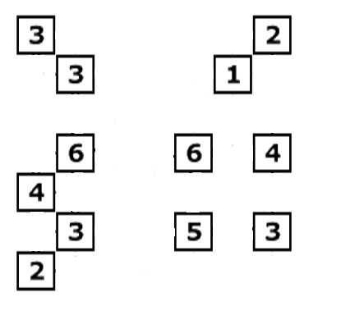

Aligned to the following standards:

CS.01; CCSS.ELA-Literacy.SL.9-10.1.D

KEY: Building Bridges

Directions:

Connect all the “islands”/boxes using these guidelines:

* You have a collection of islands, each of which contains a number.
* This number shows you how many bridges leave that island.
* Your task is to connect every island, such that any island can be reached from any other.
* A maximum of two bridges can connect two islands together.
* Bridges can only go horizontally or vertically and cannot cross each other.
* **You can only erase twice! Think carefully about your line placement before you draw them.**

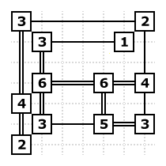

Aligned to the following standards:

CS.01; CCSS.ELA-Literacy.SL.9-10.1.D

SAE Brainstorming

Aligned to the following standards:

CS.01; CCSS.ELA-Literacy.SL.9-10.1.D

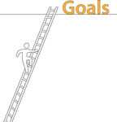SAE Goals

Directions:

Create **two** goals for your SAE by completing the following activities.

|  |
| --- |
| **Goal 1** |
| What will you accomplish with your goal? | |
| *(Specific)* |  |
| How will you measure the progress of your goal? Will you have people holding you accountable to your progress? | |
| *(Measureable)* |  |
| Is your goal attainable (doable) and do you have the time and resources to achieve it? (Spell this out; this is not a yes or no answer). | |
| *(Attainable)* |  |
| How and why is this goal important to your SAE? | |
| *(Relevant)* |  |
| When will your goal be complete? Be specific! | |
| *(Time-Bound)* |  |
|  |  |
| Now, put this all together so that you have a clear goal that is specific, measureable, attainable, relevant, and time-bound.  **Goal #1:** | |

|  |  |
| --- | --- |
| **Goal 2** | |
| What will you accomplish with your goal? | |
| *(Specific)* |  |
| How will you measure the progress of your goal? Will you have people holding you accountable to your progress? | |
| *(Measureable)* |  |
| Is your goal attainable (doable) and do you have the time and resources to achieve it? (Spell this out; this is not a yes or no answer). | |
| *(Attainable)* |  |
| How and why is this goal important to your SAE? | |
| *(Relevant)* |  |
| When will your goal be complete? Be specific! | |
| *(Time-Bound)* |  |
|  |  |
| Now, put this all together so that you have a clear goal that is specific, measureable, attainable, relevant, and time-bound.  **Goal #2:** | |

Aligned to the following standards:

CS.01; CCSS.ELA-Literacy.SL.9-10.1.D

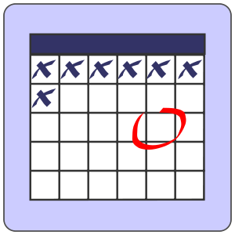SAE Planning and Timeline

Directions:

Fill in the the table to develop a timeline of specific activities that must be completed to plan, implement, and evaluate your SAE.

|  |  |  |  |  |
| --- | --- | --- | --- | --- |
| **Phase**  **(Planning, Implementation, Evaluation)** | **Strategies and Action Steps** | **What goal is this related to?** | **Resources Needed** | **Timeline (at least 1 per month)** |
| *Is this action step a part of the planning, implementation, or evaluation phase of the SAE?* | *What steps/activities are needed to move forward with the SAE?* | *What goal will this step help achieve?* | *What resources (money, time, equipment, other people, etc.) are needed to complete this step?* | *On what month and day will this be completed?* |
|  |  |  |  |  |
|  |  |  |  |  |
|  |  |  |  |  |
|  |  |  |  |  |
|  |  |  |  |  |
|  |  |  |  |  |
|  |  |  |  |  |
|  |  |  |  |  |
|  |  |  |  |  |
|  |  |  |  |  |
|  |  |  |  |  |
|  |  |  |  |  |
|  |  |  |  |  |



Aligned to the following standards:

CS.01; CCSS.ELA-Literacy.SL.9-10.1.D

My SAE Budget

Directions:

Determine what you need to make your SAE happen and if it has a cost associated with it. Even if you will not end up paying money for an item, but will exchange labor or goods to receive the item include that here.

|  |  |  |
| --- | --- | --- |
| **Capital Items**  What long term items such as equipment, buildings, breeding animals, etc. do you need related to this SAE? | | |
| **Item** | **Description** | **Cost** |
| *Name of the item*  ***Example:*** *Lawn mower* | *Describe the item and why it’s needed for the SAE*  ***Example:*** *A lawn mower that I can use to start my lawn mowing business.* | *How much will the item cost?*  ***Example:*** *$500* |
|  |  |  |
|  |  |  |
|  |  |  |
|  |  |  |

|  |  |  |
| --- | --- | --- |
| **Operational Items**  What items are needed to carry through with your SAE, but will be consumed during the project? Operational items include feed, vet services, repairs, gas, rent, etc. | | |
| **Item** | **Description** | **Cost** |
| *Name of the item*  ***Example:*** *Gasoline* | *Describe the item and why it’s needed for the SAE*  ***Example:*** *Gasoline needed to mow 3 yards a day for 4 days a week.* | *How much will the item cost?*  ***Example:*** *$70* |
|  |  |  |
|  |  |  |
|  |  |  |
|  |  |  |



Aligned to the following standards:

CS.01; CCSS.ELA-Literacy.SL.9-10.1.D